“Developing Apprenticeship: In-Company Trainer Training and Apprenticeship Promotion”
No. 2015-1-LT01-KA202-013415

Vilnius
26-10-2015

1st transnational partner meeting was held in Vilnius, Lithuania

The consortium of 8 partners from Lithuania, Latvia, Estonia, Finland and Belgium have met for their 1st transnational partner meeting within the framework of the project “Developing Apprenticeship: In-Company Trainer Training and Apprenticeship Promotion”, No. 2015-1-LT01-KA202-013415. The project is funded by the Erasmus+ Strategic Partnership programme. The project is coordinated by the PO Vilnius Jerusalem labour Market Training Centre (VJLMTC) and has started on 1st September 2015 and will last 2 years.

The meeting was opened up by the Director of VJLMTC Mindaugas Černius. The Director emphasised that the project has started at the right time since the Baltic countries are implementing changes in their national vocational training systems to accommodate the form of apprenticeship training. He expressed his belief that the project will achieve worthwhile products which will help to develop the apprenticeship in Lithuania, Latvia and Estonia. His speech was followed by the partner introductions. All partners gave presentation about their organisations.

Further, the Project Manager Rasa Lužytė has presented the tasks for the September – December period. All partners reported on the administrative tasks already carried from the start of the project up to the day of the meeting. The tasks have been accomplished 50 per cent, which is in time with the timetable.

The next subject was related to discussing the first project activities - the Needs Assessment of companies, and the Review of the existing In-Company Trainer Training provision which embraces training programmes, methodologies, guides. It has been agreed that Lithuanian, Latvian an Estonian partners will make a review of provision in their countries, which will be sent to Finish and Belgium partners. The latter will then make their suggestions for the In-Company Trainer Training Programme Model in accord to their expertise areas – theoretical (Finland) and practical (Belgium).

To go back to the project background, according to the recent research of World Economic Forum, employers in many countries report difficulties in finding suitably skilled workers. Workforce shortages can be explained by low birth rate, emigration, uncompetitive wages, unattractive working conditions, poor recruitment policies, mismatch of skills and jobs, skill gaps and deficits in specific sectors, occupations or locations. While some of these problems require difficult economic and political decisions, the skills mismatch, skill gaps and deficits could be addressed by changes in training and recruitment practices, and by facilitating labour mobility. One of the best solutions is training in the form of apprenticeship during which 50-80 per cent of training is carried out in a workplace under the supervision of an In-Company trainer who is an experienced worker in the company (workplace instructor). Apprenticeship has been recognised by the International Labour Organisation (ILO) as the most effective way of moving from education into work. In-Company trainers play a fundamental role in apprenticeship training. However, European Centre for the development of Vocational Training (CEDEFOP) study reveals that while In-Company trainers are highly professional, they would benefit from training programmes which would teach them more efficient training methods. It echoes Organisation for Economic Co-operation and Development's (OECD) statement that the central challenge in VET is to ensure that programmes meet the needs of the labour market. These studies are supported by the responses from enterprises in Lithuania, Latvia and Estonia that the existing In-Company Trainer Training Programmes lack flexibility, are too long (over 100 h), and their content often does not meet the needs of the companies. The lack of an appropriate In-Company Trainer training results in a less productive apprenticeship. For that reason, the project set out to develop and pilot an In-Company Trainer Training Programme Model. The In-Company Trainer Training Programme Model will be based on the needs of companies, it will be much more flexible than the existing ones and will teach the In-Company trainers to train the apprentices in the most efficient and effective ways to match their skills for the job.

There is also a constant struggle of attracting apprentices since vocational education is considered less attractive than university education. In Lithuania, Latvia and Estonia, engaging into studies within the vocational education field is often viewed as a personal failure to achieve better in life. Therefore, more promotion of and information about the vocational education, especially in the form of apprenticeship is required. To address these problems, the project will seek to develop and test the Concept of Apprenticeship Promotion. The Concept will target a wide spectrum of potential apprentices and will promote the positive image of apprenticeship.

The objectives of the project are:
I. To increase the supply of the qualified labour staff for the economic sectors suffering from the workforce shortage and to help to match skills for the job, cover skill gaps as well as skill deficits through efficient apprenticeship training.
II. To increase the popularity of apprenticeship training through the development of a systematic apprenticeship promotion.

To achieve these objectives, the project will create the following 2 Intellectual Outputs:
1. An In-Company Trainer Training Programme Model
2. A Model Concept for Apprenticeship Promotion

Project activities:
Output 01
1. Needs assessment and provision Review
2. Selection of methodology for the creation of in-company trainer training programme
3. Development of in-company trainer training programme model
4. Methodology kit for in-company trainers.
5. Adaptation of in-company trainer training programme model to national specifics. Compliance with national qualification institutions.
6. Piloting of in-company trainer training programme.

Output 02
1. Development of concept model for apprenticeship promotion
2. Adaptation of concept model for apprenticeship promotion to national specifics.
3. Piloting of concept model for apprenticeship promotion.

The Intellectual Outcomes are planned to be developed in Latvia, Lithuania and Estonia with the expertise support from Finland and Belgium. Organisations participating:

Vilnius Jerusalem Labour Market Training Centre (the applicant, Lithuania)
Centre of Expertise in Productivity (Finland)
Actions Intégrées de Développement asbl (Integrated Development Action) (Belgium)
Lithuanian Qualifications and Vocational Training Development Centre
Employers’ Confederation of Latvia
Lithuanian Engineering Industry Association “Linpra”
Lithuanian Builders’ Association
Estonian Employers’ Confederation

Photos of the meeting:

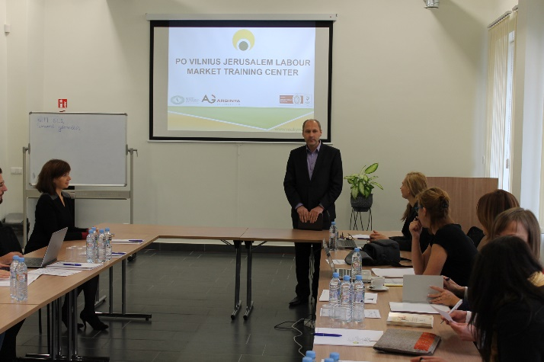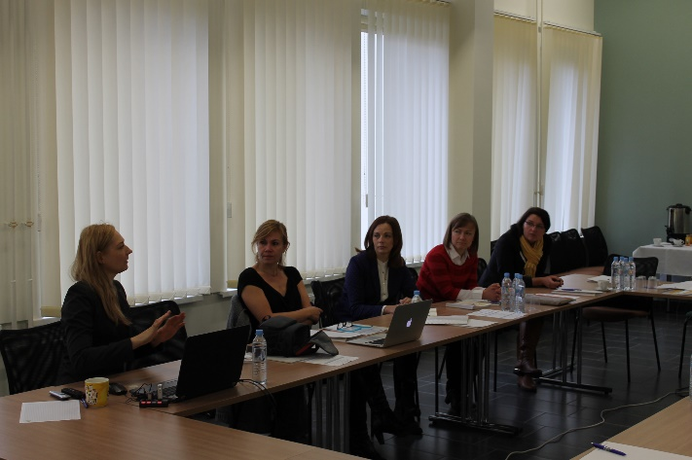

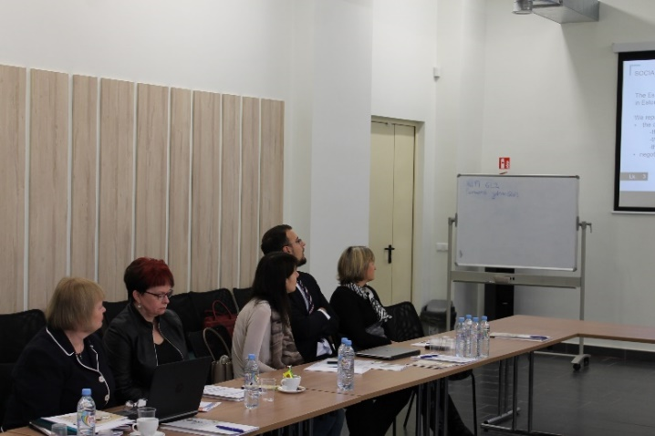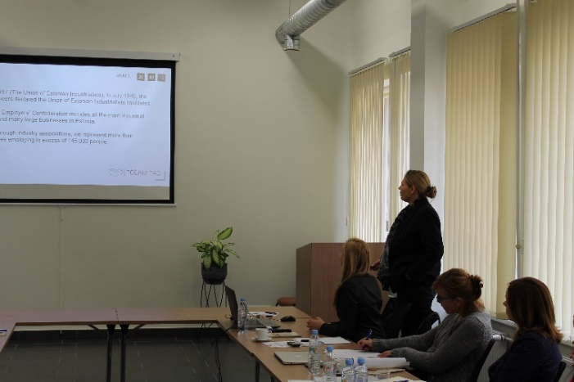

This project is funded by the European Commission, the Erasmus Programme.
This document reflects the views only of the author,
the Commission can not be held responsible for any use of the information contained therein.

